**TECHNOLOGY FOR TEACHING AND LEARNING 1**

**Name: Vincent Galvez**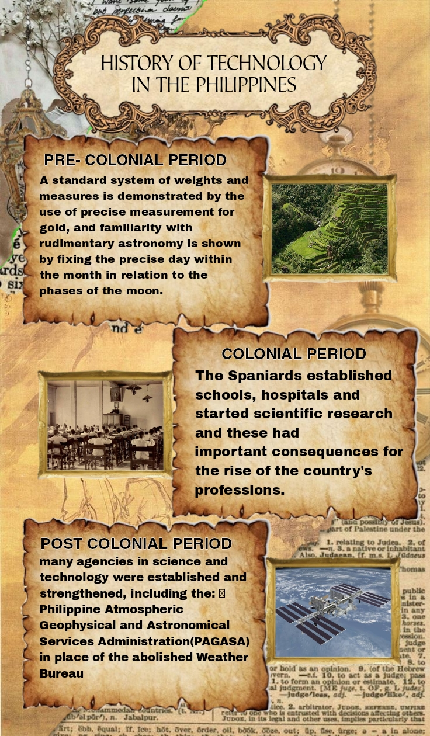

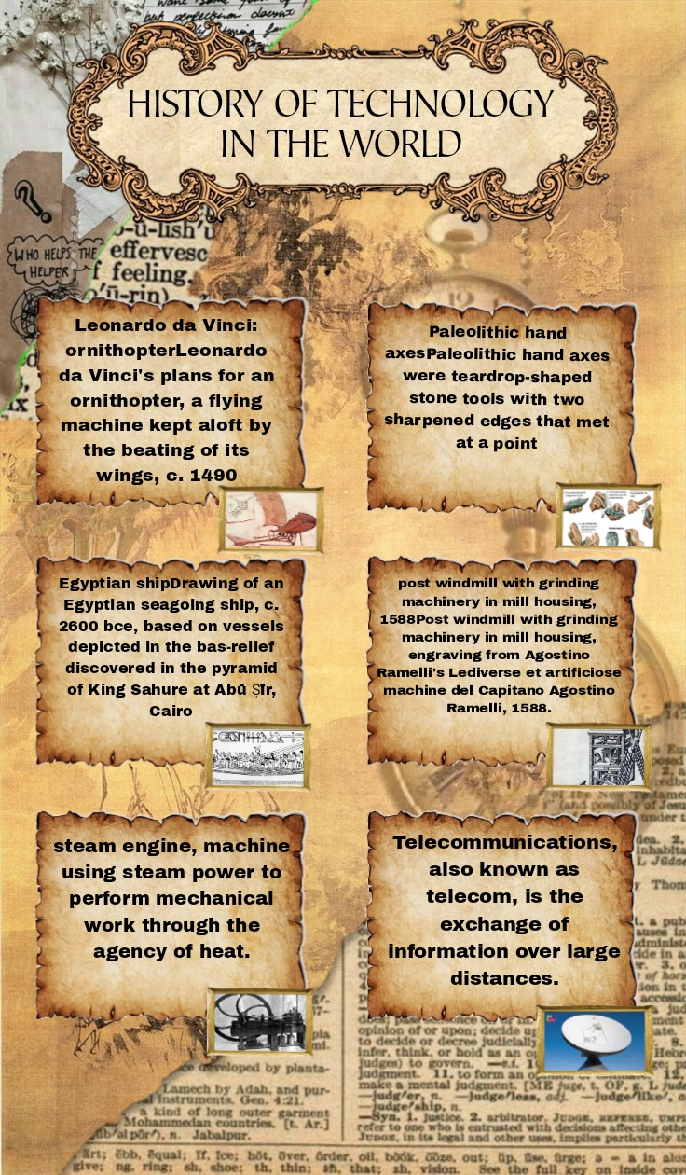

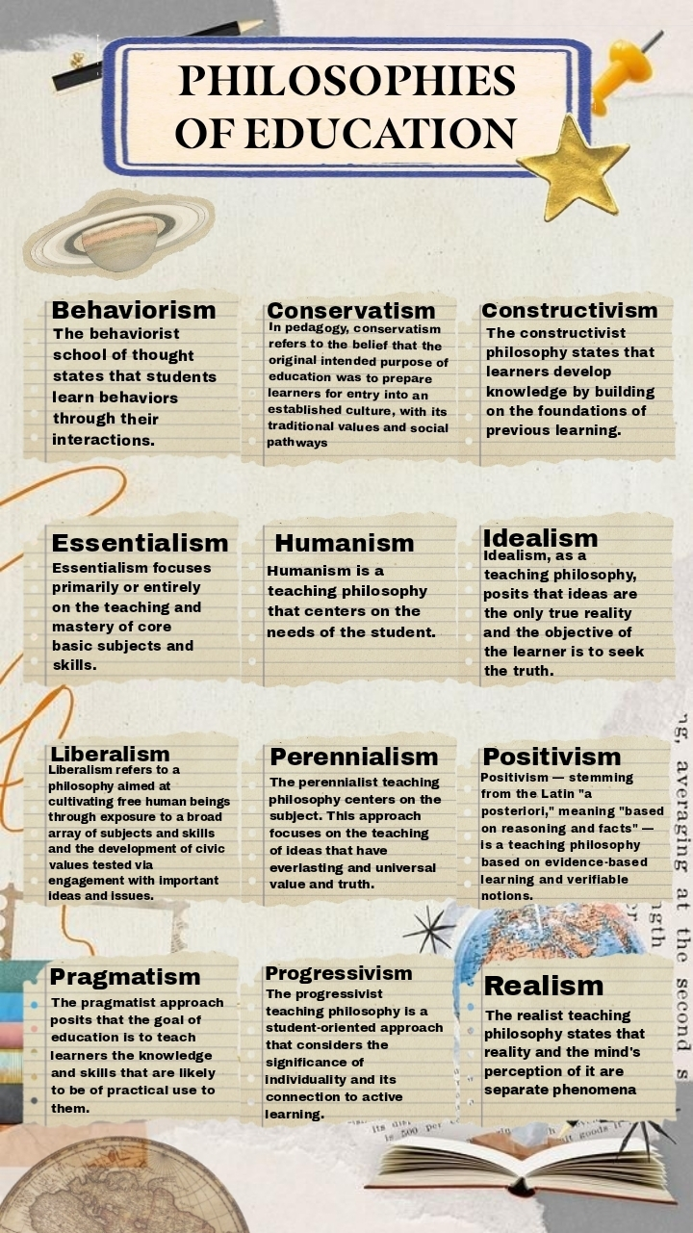

**THE HISTORY OF TECHNOLOGY IN THE PHILIPPINES**

This document provides a brief history of science and technology in the Philippines from the Stone Age to the Spanish Colonial Period. It describes how early Filipinos developed simple tools in the Stone Age and learned metallurgy during the Iron Age. By the 10th century AD, they were engaged in inter-island trade and had developed boat building technology. During the Spanish Colonial period, the Spanish introduced formal Western-style education and founded universities, focusing on fields like biology, chemistry, and medicine. They also contributed to engineering by constructing infrastructure.   
Science and technology in the Philippines describes scientific and technological progress made by the Philippines and analyses related policy issues. The main agency responsible for managing science and technology (S&T) is the Department of Science and Technology (DOST). There are also sectoral councils for Forestry, Agriculture and Aquaculture, the Metal Industry, Nuclear Research, Food and Nutrition, Health, Meteorology, Volcanology and Seismology. Science and technology is an interdisciplinary topic encompassing science, technology, and their interactions Science is a systematic enterprise that builds and organizes knowledge in the form of explanations and predictions about nature and the universe.

**THE HISTORY OF TECHNOLOGY IN THE WORLD**

The history of technology is the history of the invention of tools and techniques by humans. Technology includes methods ranging from simple [stone tools](https://en.wikipedia.org/wiki/Stone_tools) to the complex [genetic engineering](https://en.wikipedia.org/wiki/Genetic_engineering) and information technology that has emerged since the 1980s. The term *technology* comes from the Greek word *techne*, meaning art and craft, and the word *logos*, meaning word and speech. It was first used to describe [applied arts](https://en.wikipedia.org/wiki/Applied_arts), but it is now used to describe advancements and changes that affect the environment around us.

3.3 million years ago: The first tools  
The history of technology begins even before the beginning of our own species. Sharp flakes of stone used as knives and larger unshaped stones used as hammers and anvils have been uncovered at Lake Turkana in Kenya. The tools were made 3.3 million years ago and thus were likely used by an ancestor such as [Australopithecus](https://www.britannica.com/topic/Australopithecus).

**PHILOSOPHIES OF EDUCATION**

the philosophy of education explores fundamental questions about the nature and purpose of education. It encompasses a range of perspectives and theories, aiming to understand how education should be conducted and what goals it should achieve. Here are some key aspects of educational philosophy.

The philosophy of education is the branch of applied philosophy that investigates the nature of education as well as its aims and problems. It also examines the concepts and presuppositions of education theories. It is an interdisciplinary field that draws inspiration from various disciplines both within and outside philosophy, like ethics, political philosophy, psychology, and sociology. Many of its theories focus specifically on education in schools but it also encompasses other forms of education. Its theories are often divided into descriptive theories, which provide a value-neutral description of what education is, and normative theories, which investigate how education should be practiced.